AFTER PRAISE FROM NO DEPRESSION, AIRPLAY FROM WMOT & WXPN, & PHILLY FOLK FEST APPEARANCE, MELANIE BRULÉE PLOTS SUMMER TOUR

‘FIRES FLOODS & THINGS WE LEAVE BEHIND’ TO SEE VINYL RELEASE AUG. 2

Melanie Brulée – the songwriter who played an official SXSW showcase this year and has lived in Paris, Nashville, and Australia and whose new album speaks to leaving destructive people and habits behind – will launch a North American tour July 1. Spotify put her on its official Down Home Country and Renegade Folk playlists. The Boston Herald described her music as “The lonesome ballads and rootin’-tootin’ barnburners[,] tremolo guitar and the high-plains-drifter whistling straight out of a spaghetti Western.”

No Depression said, “Melanie Brulée’s new album, 'Fires, Floods & Things We Leave Behind,' explores the wide open spaces of the Wild West — and she’s got the voice to fill it.” The Boston Globe praised her “echoing, spaghetti-western sound,” going on to said that she “carries it off with aplomb.”

The album will be released on vinyl August 2.

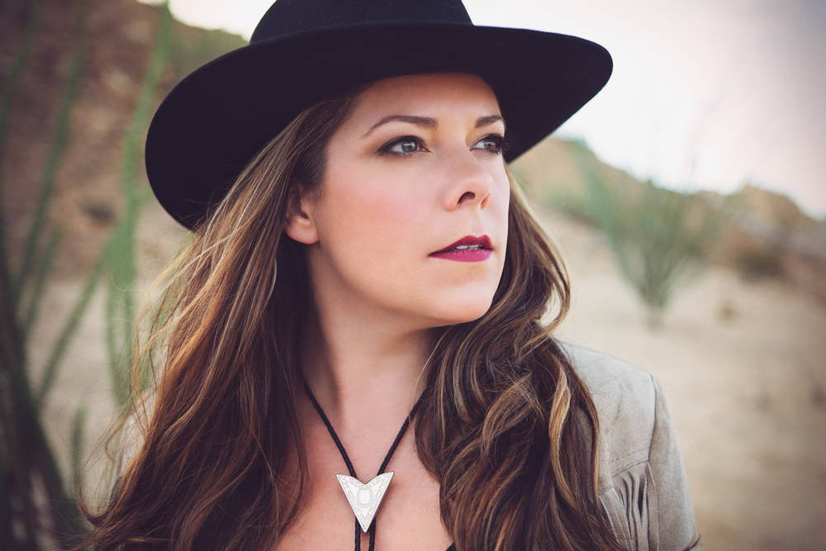

Guitar Girl Magazine interviewed Brulée: https://guitargirlmag.com/interviews/melanie-brulee-fires-floods-things-we-leave-behind/

Melanie Brulée Tour Dates

July 1 – Cornwall, ONT - Cornwall Bandshell (w/ Barstool Prophets)
July 5 - Ottawa ONT - RBC Bluesfest
July 6-7 – Orillia, ONT - Mariposa Folk Festival
July 13 – Mansfield, PA – Greyson Series
July 18 – Wilmington, DE - Ladybug Festival
July 19 - Chadds Ford, PA - Brandywine River Art Museum
July 20 – Philadelphia, PA – Philadelphia Folksong Society
July 22 - Wilmington, DE - Live! in the Parks, Rockford Park
July 24 – Ithaca, NY - Maxie’s Supper Club (w/ Janet Batch)
July 25 – Hartford, CT - Hog River Brewing Co.
July 27 – Huntington, NY - Huntington Folk Festival
July 28 – Somerville, MA - Americana Sundays at Thunder Road (w/ Highlife Special)
July 31 – Lancaster, PA – Tellus 360
August 1 - Asbury Park, NJ - Asbury Park Yacht Club (w/ Jackson Pines)
August 3 – Baltimore, MD – Chez Bill Series
August 4 – New York, NY – Rockwood Music Hall

For more information on Melanie Brulée, please contact Nick Loss-Eaton at nick.losseaton@gmail.com or 718.541.1130.

We acknowledge the support of the Canada Council for the Arts in making this project possible.

